Topic 1 – Mini Activity:
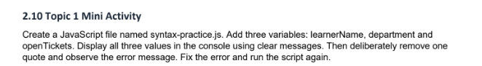
Code structure:
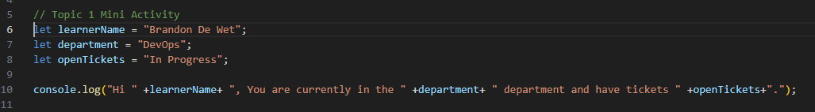
Testing:
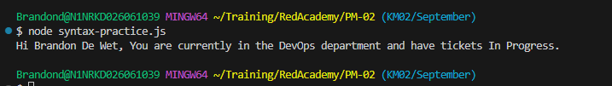
Breaking the code:
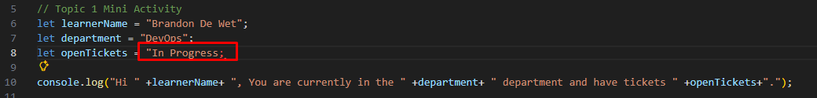
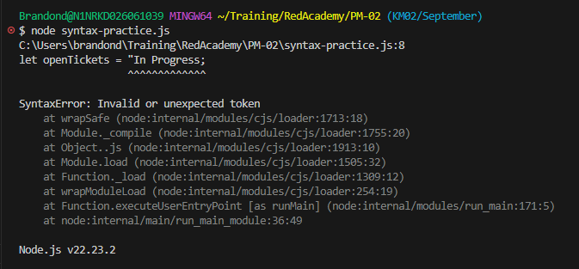

Topic 2 – Mini Activity:
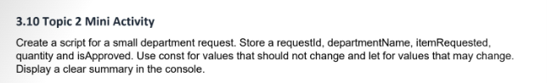
Code structure:
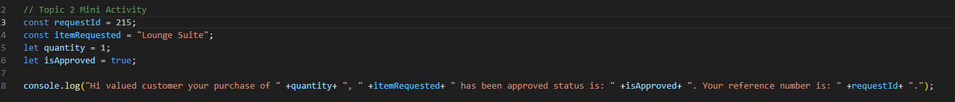
Testing:

Topic 3 - Mini Activity:
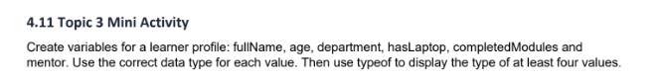
Code structure:
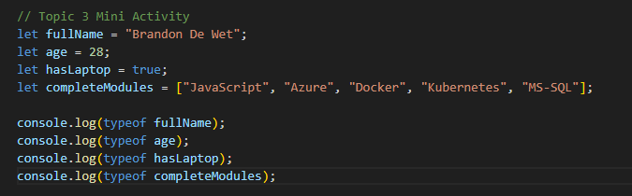
Testing:
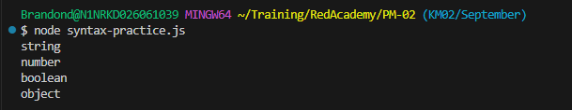

Topic 4 - Mini Activity:
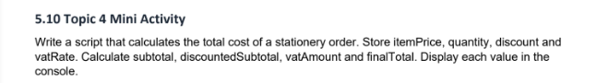
Code structure:
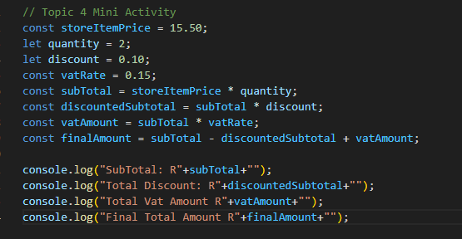
Testing:
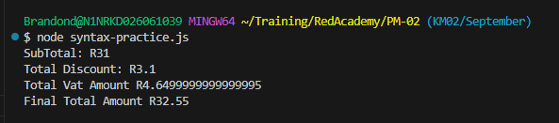

Topic 5 - Mini Activity:

